Week 2: Implantation and Bilaminar Disc Formation

Key Timeline and Events
- Day 7 (Early Implantation):
  - Hatched blastocyst apposes to endometrium (fundus wall, posterior preferred)
  - Trophectoderm adheres via integrins/L-selectins to uterine selectins.
  - Syncytiotrophoblast invades decidua, forming lacunae for maternal blood pooling (start of hemochorial placentation).
- Days 8-9 (Deep Implantation):
  - Syncytiotrophoblast erodes spiral arteries (MMPs/secreted proteases)
  - Cytotrophoblast proliferates as stem cells
  - Embryonic pole embeds ~0.2 mm
  - Abembryonic pole remains superficial
  - hCG detectable in maternal serum (~5 mIU/mL).
- Days 10-12 (Bilaminar Disc Emergence):
  - Embryoblast (inner cell mass) flattens into bilaminar disc (~0.1-0.2 mm oval/pear-shaped).
  - Epiblast (dorsal, columnar) → embryo body; hypoblast (ventral, cuboidal) → extraembryonic endoderm.
  - Cavities form: Amniotic (epiblast-derived, small) and primary yolk sac (hypoblast + exocoelomic membrane).
- Days 13-14 (End of Week 2):
  - Uterine epithelium regenerates over abembryonic pole (covering lacunae)
  - Lacunar networks connect to maternal sinusoids (primitive circulation).
  - Decidua capsularis forms around conceptus
  - Histiotrophic nutrition peaks via gland secretions (glycoproteins, lipids).
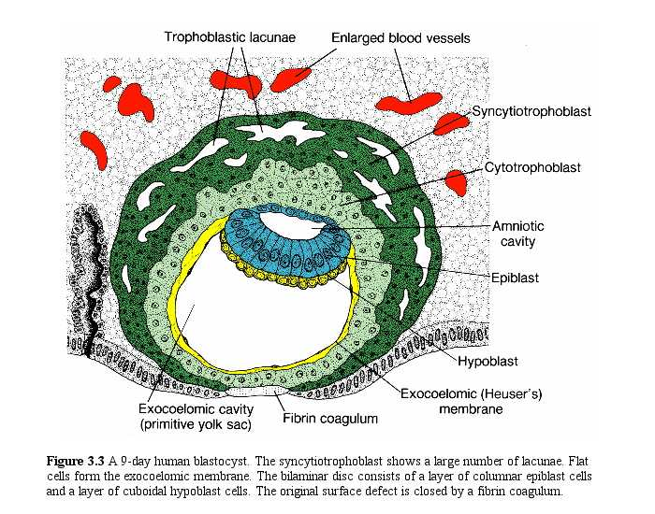
Key Structures Formed
- Trophoblast Differentiation: Syncytiotrophoblast and Cytotrophoblast
- Bilaminar Disc: Epiblast (future ectoderm/mesoderm/endoderm via gastrulation) and hypoblast (yolk sac endoderm).
- Adhesions at cranial (prechordal plate precursor) and caudal (cloacal membrane) ends.
- Extraembryonic Membranes:
  - Amniotic cavity (roof: amnioblasts from epiblast)
  - Yolk sac (floor: hypoblast, nutrient role until week 8)
  - Chorion (trophoblast + extraembryonic mesoderm, future placenta).
- Decidua:
  - Progesterone and Leukemia inhibitory factor (LIF) induced stromal changes
  - Natural Killer cells (uNK cells) of uterus remodel arteries for low-resistance flow
[YOUTUBE] https://youtu.be/ju6JemauyXQ

